Name: Chetana Shivkiran Patil
PRN: 2020BTECS00043
Batch:T6
SET Assignment 8
Q 1. What are the prerequisites for installing the TestLink tool.
Since TestLink is a web-application it follows the concept of client/server. It means that TestLink can be installed centrally on a server and users can interact with it through web browsers using a website from any computer· Web Server − TestLink supports 2.2.2.1. However, it can work with any latest web server software. TestLink only uses .php file. Configure the web server with .php extension only. PHP − The web server should support
PHP- It can be installed as CGI or any other integration technology. It is recommended to use 5.3.8 PHP version.
Mandatory PHP Extensions − Extensions for RDBMS are mysqli, pgsql, oci8, sqlsrv. Mbstring is required for Unicode – UTF-8 support.
Optional Extensions − Curl, GD, Fileinfo
Database − TestLink requires database to store its data. MySQL (5.5.16) is
recommended.
FileZilla FTP Server − FileZilla FTP Server 0.9.39 is required to install XAMPP as optional.
Q 2. Install TestLink tool on your machine (Provide screen shots for successful installation and login)
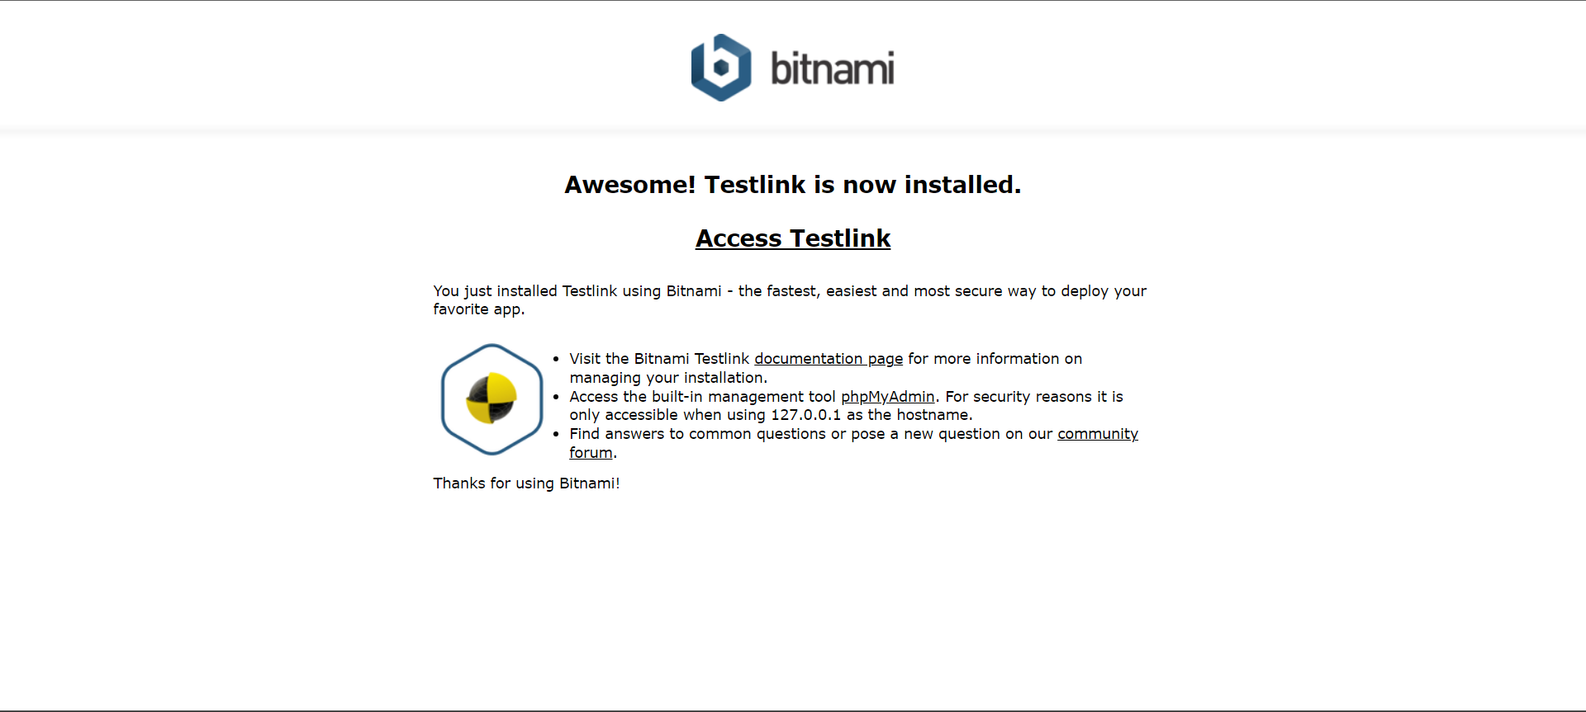

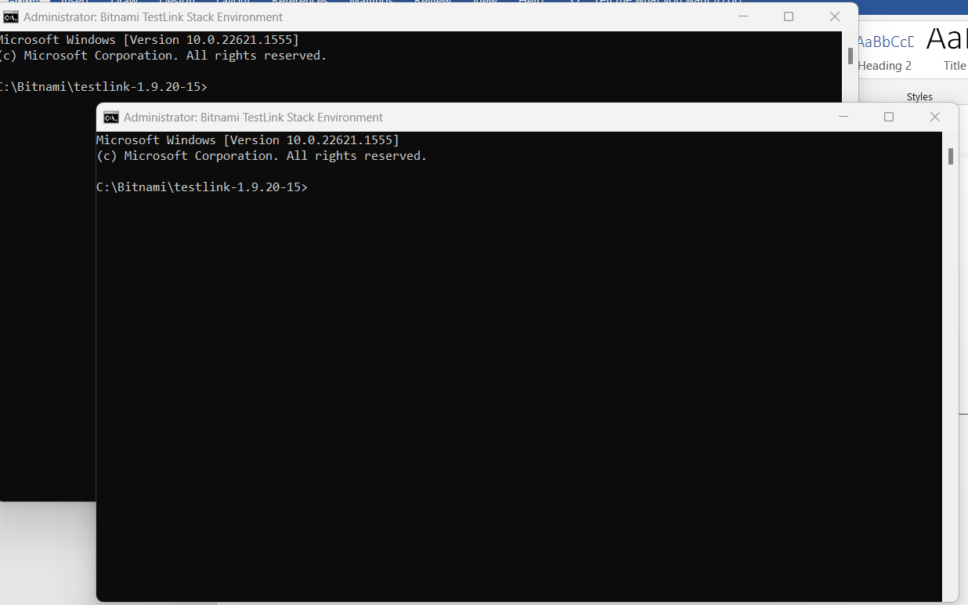

Succesful Login:
